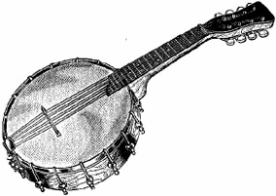 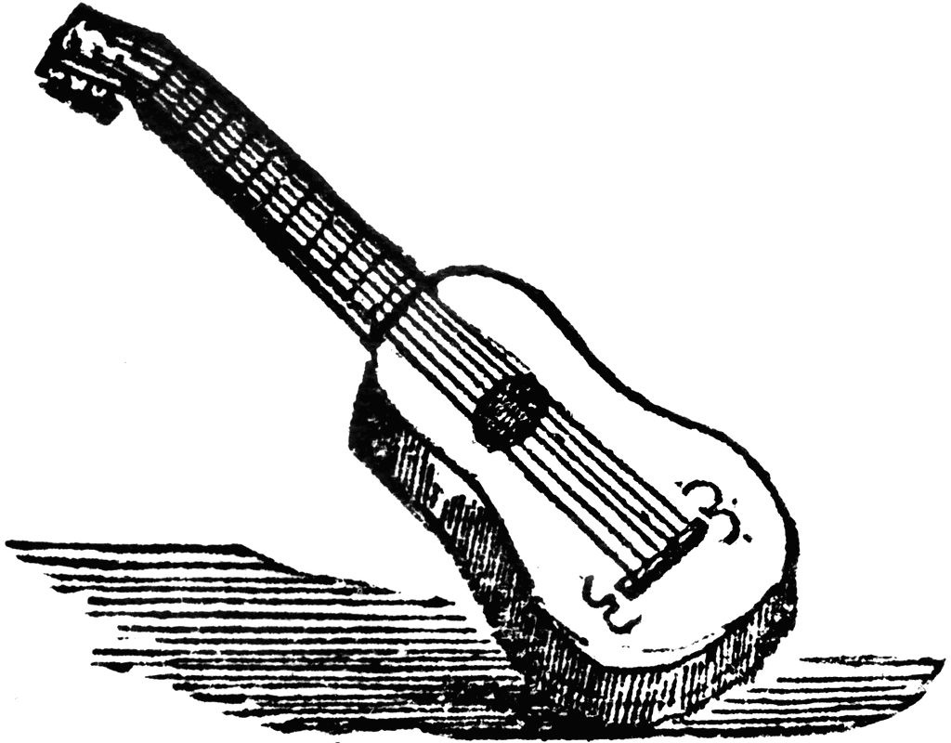

Name

Country Music

Use the internet to answer the following questions and identify the following instruments.

1. Write the definition of country music below.

_____________________________________________________________________________________

_____________________________________________________________________________________

1. List several characteristics that make country music identifiable.

_____________________________________________________________________________________

_____________________________________________________________________________________

_____________________________________________________________________________________

_____________________________________________________________________________________

Identify the following country music instruments below: Choose from the following terms: Harmonica, Drum set, guitar, fiddle, banjo, electric guitar.

